**ASSIGNMENT 2 FRONT SHEET**

|  |  |  |  |
| --- | --- | --- | --- |
| **Qualification** | **BTEC Level 5 HND Diploma in Business** | | |
| **Unit number and title** | **Unit 30: Application Development** | | |
| **Submission date** | 7-4-2021 | **Date Received 1st submission** |  |
| **Re-submission Date** |  | **Date Received 2nd submission** |  |
| **Student Name** | Phan Bao Hoang | **Student ID** | GCH190102 |
| **Class** | GCH0802 | **Assessor name** | Lai Manh Dungz |
| **Student declaration**  I certify that the assignment submission is entirely my own work and I fully understand the consequences of plagiarism. I understand that making a false declaration is a form of malpractice. | | | |
|  |  | **Student’s signature** |  |

**Grading grid**

|  |  |  |  |  |  |  |  |
| --- | --- | --- | --- | --- | --- | --- | --- |
| **P4** | **P5** | **P6** | **M3** | **M4** | **M5** | **D2** | **D3** |
|  |  |  |  |  |  |  |  |

|  |  |  |
| --- | --- | --- |
| **❒ Summative Feedback: ❒ Resubmission Feedback:** | | |
| **Grade:** | **Assessor Signature:** | **Date:** |
| **Internal Verifier’s Comments:** | | |
| **Signature & Date:** | | |

Contents

1 Introduction 5

2 Interview 5

3 Survey 6

4 Folder structure of the application 11

5 Final screenshots and source code samples of the application with explanation 14

5.1 Login 14

5.2 Admin system 16

5.3 Training Staff system 18

5.4 Trainer System and trainee system 21

6 Screenshots of using GitHub to manage the source code 23

7 Test case 24

8 Answer question of survey and interview 26

9 Evaluate the strengths and weaknesses of the application 32

Figures

Figure 1-survey questions 7

Figure 2-number of people answered 7

Figure 3-First question 8

Figure 4-second question 8

Figure 5-Third question 8

Figure 6-fourth question 9

Figure 7-fifth question 9

Figure 8-sixth question 9

Figure 9-seventh question 10

Figure 10-eighth question 10

Figure 11-Folder structure 11

Figure 12-Controller’s structure 11

Figure 13-Model's structure 12

Figure 14-View's structure 12

Figure 15-Login 14

Figure 16-Login (controller) 15

Figure 17-message "Something wrong!" 15

Figure 18-Error not entering email or password 16

Figure 19-Admin interface 16

Figure 20-Create new Trainer 17

Figure 21-List of Trainers 18

Figure 22-Training Staff System interface 18

Figure 23-View all Trainees 19

Figure 24-Setting account 20

Figure 25-Trainer system interface 21

Figure 26-View Profile 21

Figure 27-View Course 22

Figure 28-View classes 22

Figure 29-GitHub (manager source code) 23

Figure 30-First answer 26

Figure 31-second answer 26

Figure 32-Third answer 27

Figure 33-fourth answer 27

Figure 34-fifth answer 28

Figure 35-sixth answer 28

Figure 36-seventh answer 29

Figure 37-eighth answer 29

# Introduction

After completing the FPT training system, we conducted interviews and interviews with some people who have experienced the system to give an objective perspective to the entire current system. This report will give information about the system, how to manage the source code as well as user reviews after experiencing the system.

# Interview

We conduct direct interviews with 3 people who have experienced our system to specifically evaluate the performance and interaction of the system with users. To details, we interview 3 people: Nguyen Van Duc, Doan Anh Tu and Vu Ngoc Tu.

**Question 1: Can you introduce yourself a little bit?**

**Question 2: Have you ever used a system similar to ours?**

**Question 3: How do you find our system different from other systems?**

**Question 4: What do you think about the functions of the system?**

**Question 5: What do you think about the performance of the system?**

**Question 6: Are you satisfied with our system? What makes it difficult for you to use our system?**

**Question 7: What functions do you think our system needs to improve in the future?**

# Survey

We have tested the system with more than 10 people, which include all 4 roles: admin, trainer, trainee, training staff. We do a survey to get over view of their experience about the System after using. From that, we can know what user thinks and what is the cons and pros of the System, what we need to improve. Below is our question:

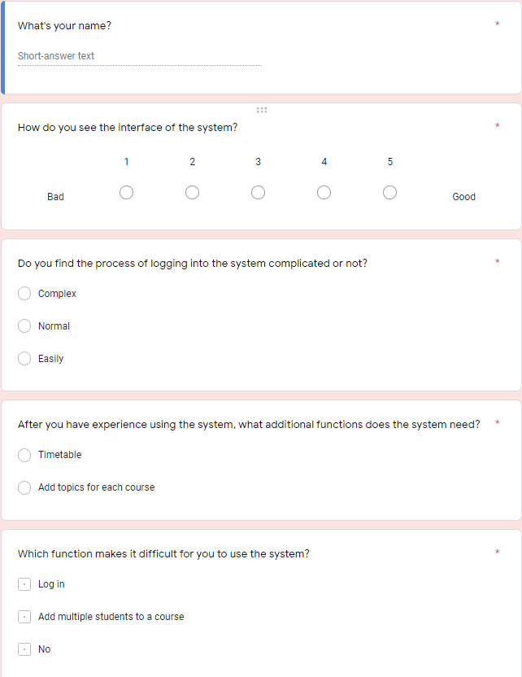

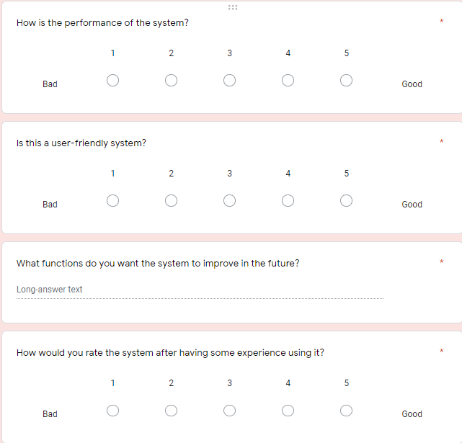

Figure -survey questions

We have 8 questions to ask people about our PFT training system. All questions aim to objectively evaluate the friendliness and convenience of the system.

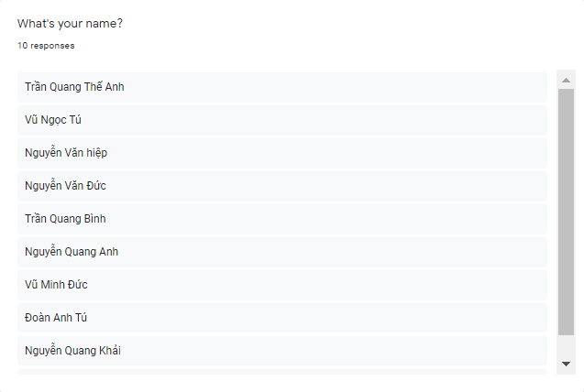

Figure -number of people answered

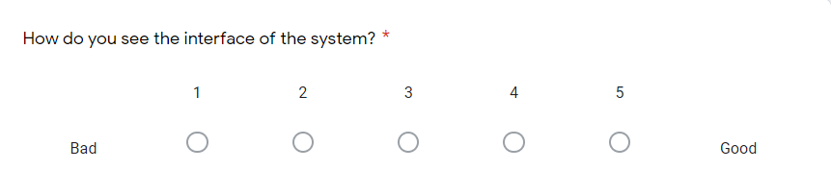

Figure -First question

In first question, we ask people about interface of FPT training system. To details, it about: layout, color, …

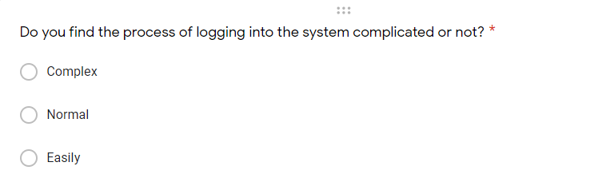

Figure -second question

In second question, we ask people about process of logging into the system.

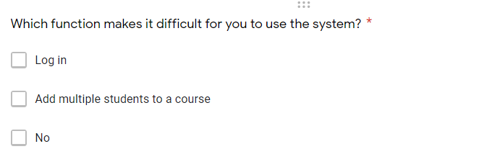

Figure -Third question

In this question, we ask people about a function in the system that makes people uncomfortable to use.

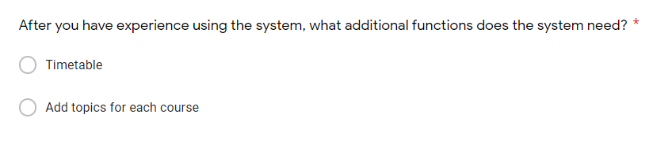

Figure -fourth question

In this question, we ask people to choose the most necessary function for the system.

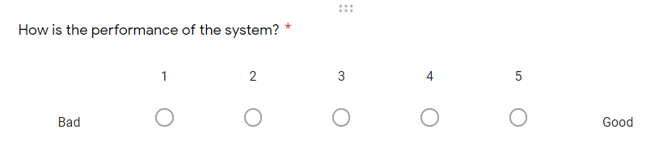

Figure -fifth question

In this question, we ask people about performance of system.

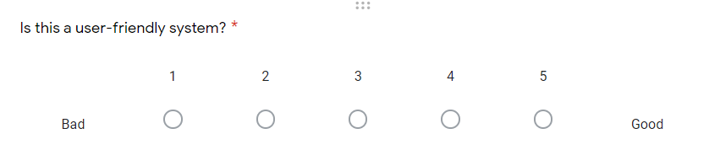

Figure -sixth question

In this question, we ask people about user-friendly of system.

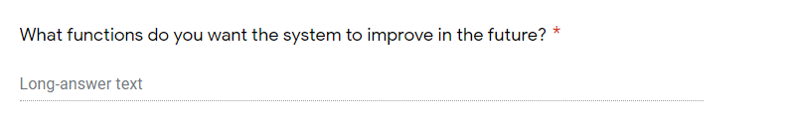

Figure -seventh question

This is an open-ended question asking people to give suggestions for functions that need improvement or future development.

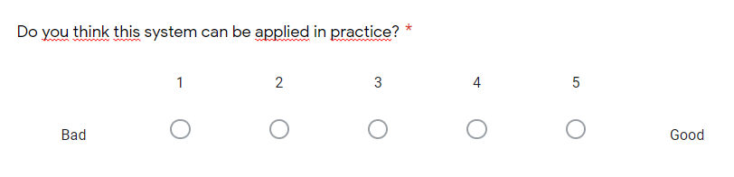

Figure -eighth question

In the last question, we would like to know what people think when this project is put into practice.

# Folder structure of the application

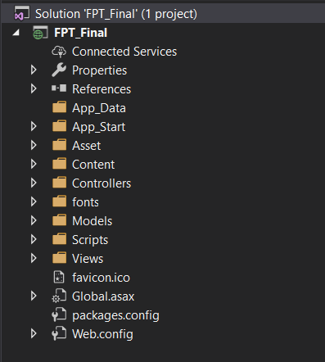

Figure -Folder structure

In this project, I use MVC model structure to perform. In here, there are three main parts: Controllers, Models and Views. Besides, the project also has several other folders to support such as: Asset folder store images, Content folder store CSS files, Fonts folder store font files, Scripts folder stores jQuery framework and script files. To details, this report will display about 3 main parts:

1. Controllers

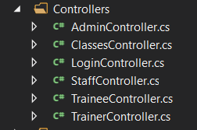

Figure -Controller’s structure

In Controller folder, project has 6 files include: LoginController.cs, AdminController.cs, StaffController.cs, TraineeCotroller.cs, TrainerController.cs and ClassesController.cs. Each controller files also have its own code to query the database of project. To details, LoginController.cs file wrote code for login page to help people can login to system by their Email. AdminController.cs file, StaffControler.cs file, TrainerController.cs file and TraineeController.cs fille wrote code functions of all admin functions of different types of users. ClassesController.cs file is file which wrote code to help Staff can create new class for trainers and trainees

1. Models

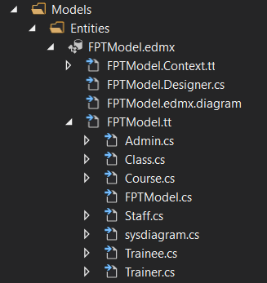

Figure -Model's structure

Model folder is place which were connected to SQL server to store database of project. In FPTModel.tt folder has many files: Admin.cs, Class.cs, Staff.cs, Trainer.cs, Trainee.cs; they are also tables of database.

1. Views

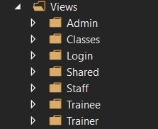

Figure -View's structure

Views folder is place which store View files of controllers. To details, Views folder has 7 folders smaller, and each of them also store all of files “.cshtml” for corresponding controller.

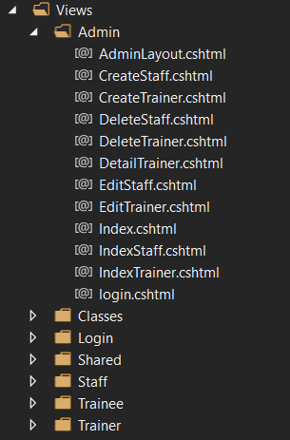

Each file “.cshtml” will wrote code by HTML to create user interface for each corresponding user.

# Final screenshots and source code samples of the application with explanation

## Login

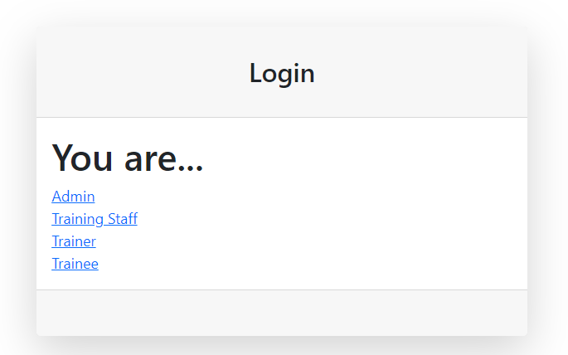

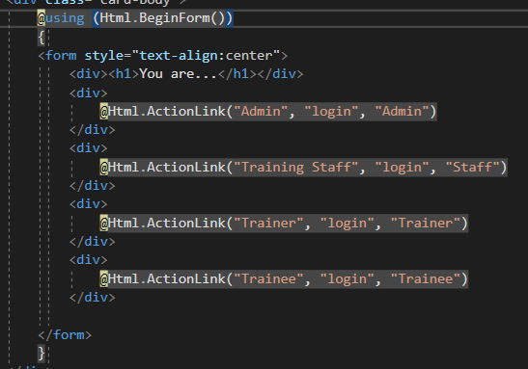

Figure -Login

In here, program use three “ActionLink” to navigate to the respective login page when the user selects

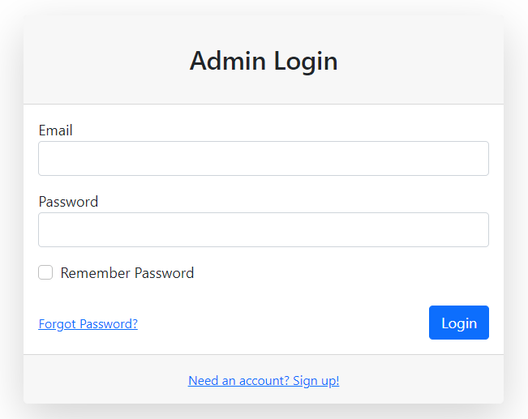

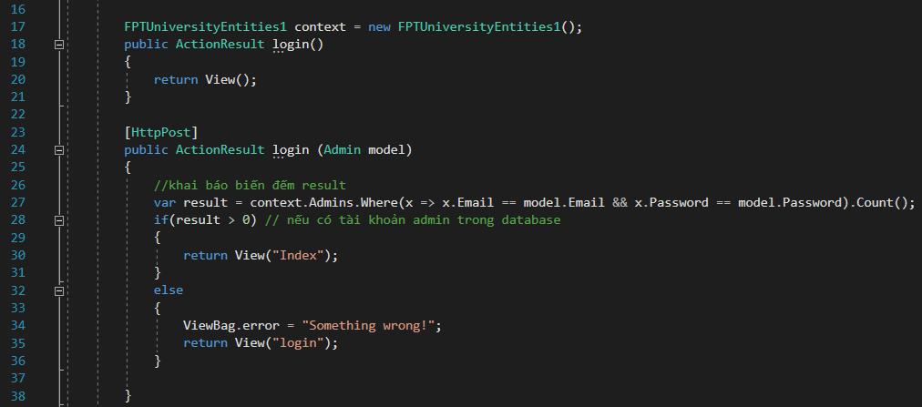

Figure -Login (controller)

When user choose their roles, program will navigate to login interface as above. People must input correct their Email and Password to login to the system. In source code, program declare a variable “result” to count all of accounts in database those whose account and password are the same as the user entered. If program count more than 0 accounts, user will login to system, but there is no account program will give a massage “Something wrong!”

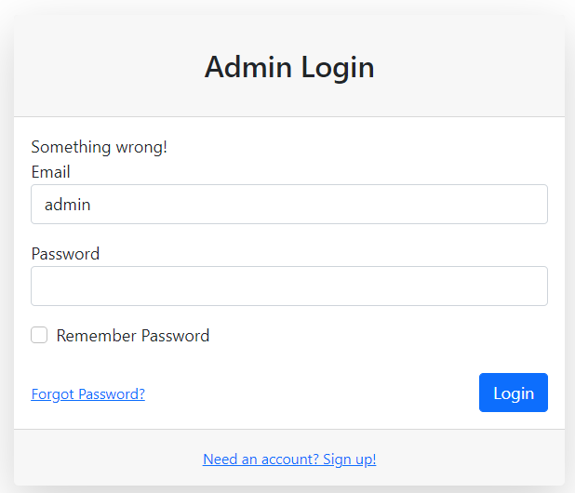

Figure -message "Something wrong!"

Besides, with login page of Staff, Trainer and Trainee, user must enter full and correct format of email ( @gmail.com). If not, system also give error massages.

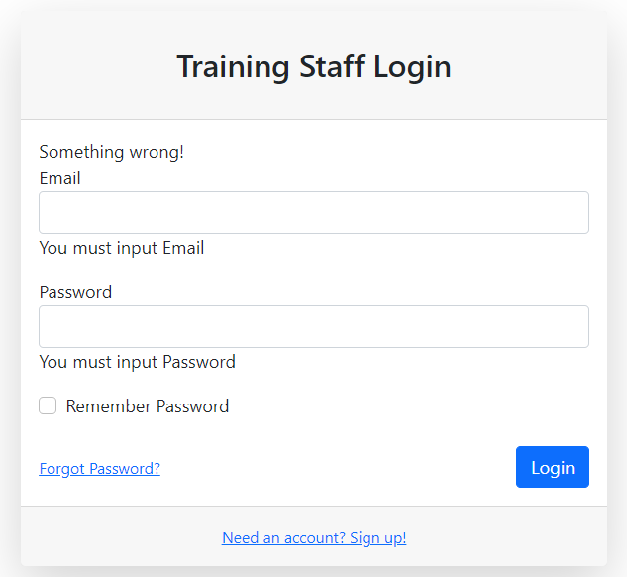

Figure -Error not entering email or password

## Admin system

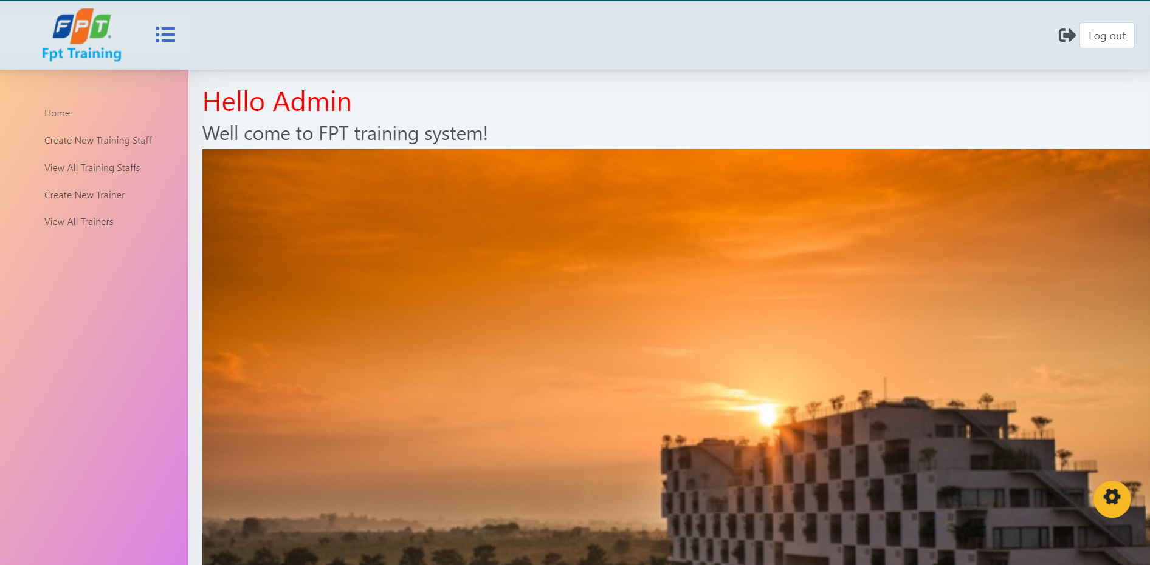

Figure -Admin interface

If user is admin, after they login to system, they will come to interface of admin system. In here, there is a logo of FPT in left corner, a “log out” input in right corner. Besides, program has a menu column, it includes: Home, Create new Training Staff, View All Training Staffs, Create New Trainer and View All Trainers. Each choice in menu is also a “ActionLink” to navigate.

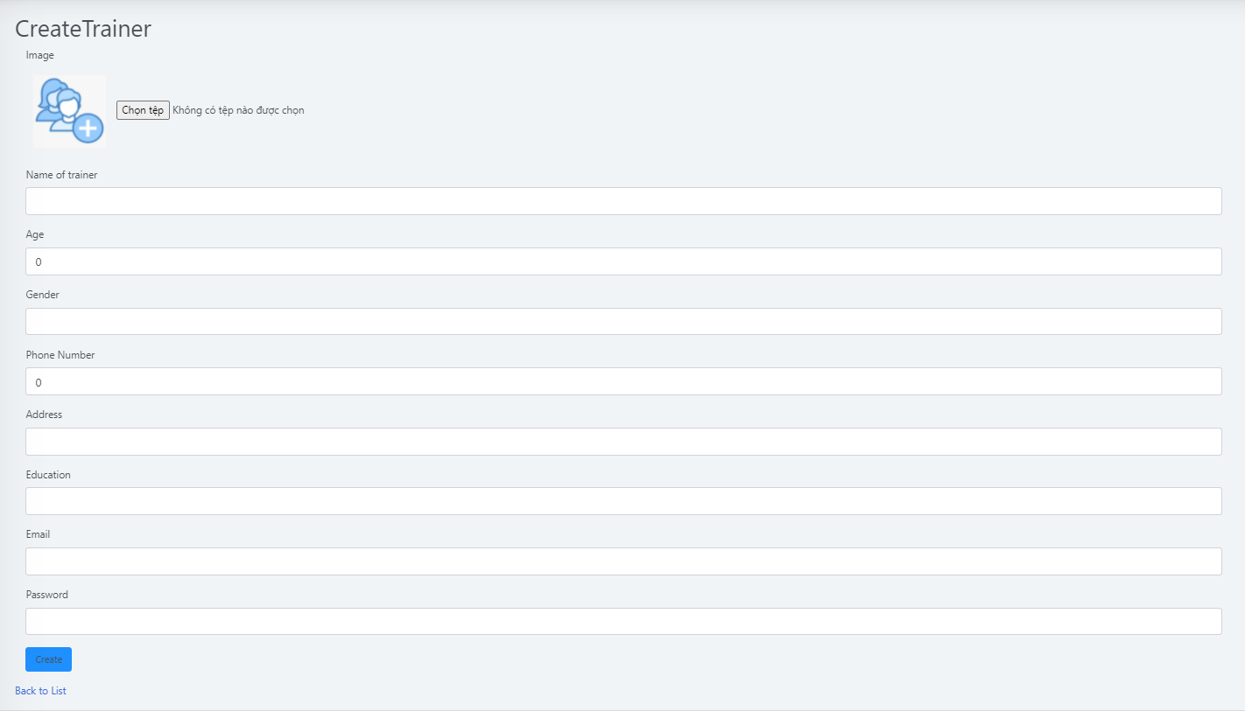

Figure -Create new Trainer

In here, Admin can create new Trainer account also new Trainer profile. Admin can choose image of trainer from admin’s computer, and input information of that trainer. When Admin input completely, they click to “Create” button to save it to database. So New Trainer will be display in list of Trainers.

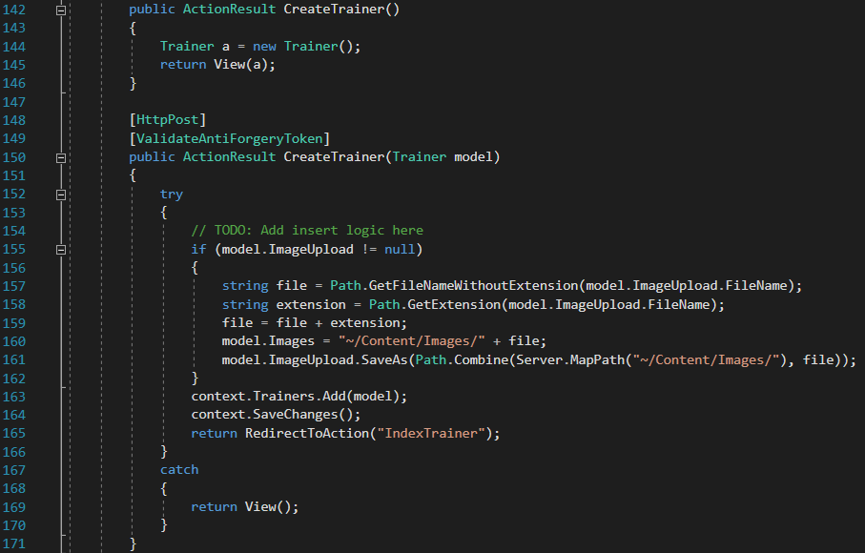

Program has two Action are: CreateTrainer() with method get and CreateTrainer(Trainer model) with method post. In method get, program declare new Trainer a and return. In method post, program use try – catch to catch user error. If user doesn’t input full information of trainer, system will return original Create page. Program declare a variable ImageUpload in Trainee.cs to up load new image for trainee in system.



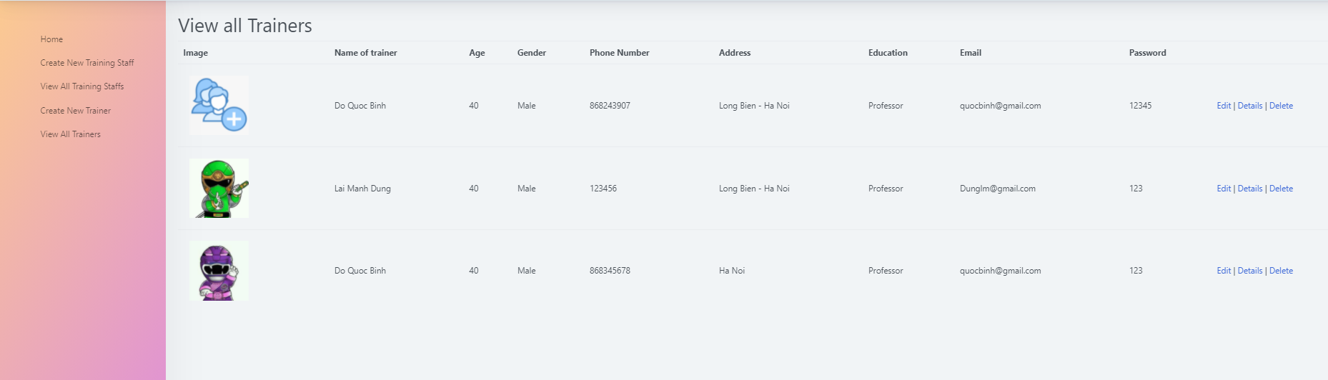

Figure -List of Trainers

Admin can click to “Edit” button to edit information of trainer, “Detail” button to view information of trainer specifically, “Delete” button to delete a trainer form system.

## Training Staff system

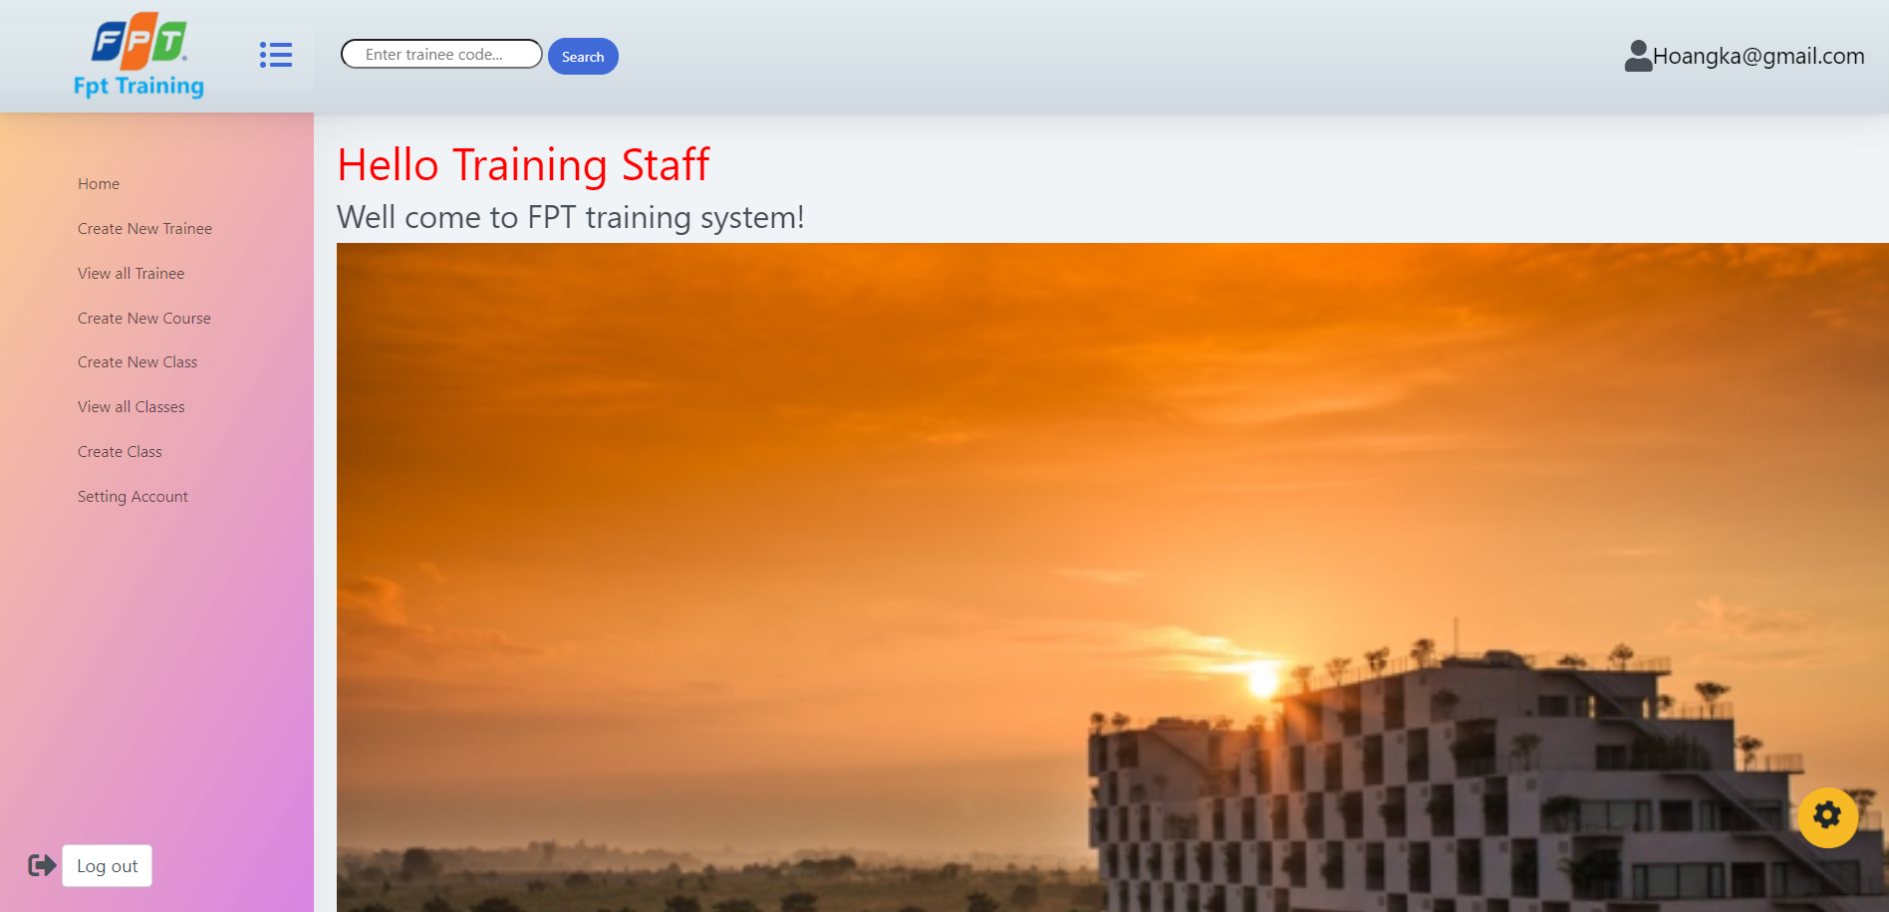

Figure -Training Staff System interface

In here, in addition to the FPT logo and the menu column, the system can display the email of the user who has just logged into the system. Furthermore, the system has a search bar for the training staff to enter the trainee's name to find them.

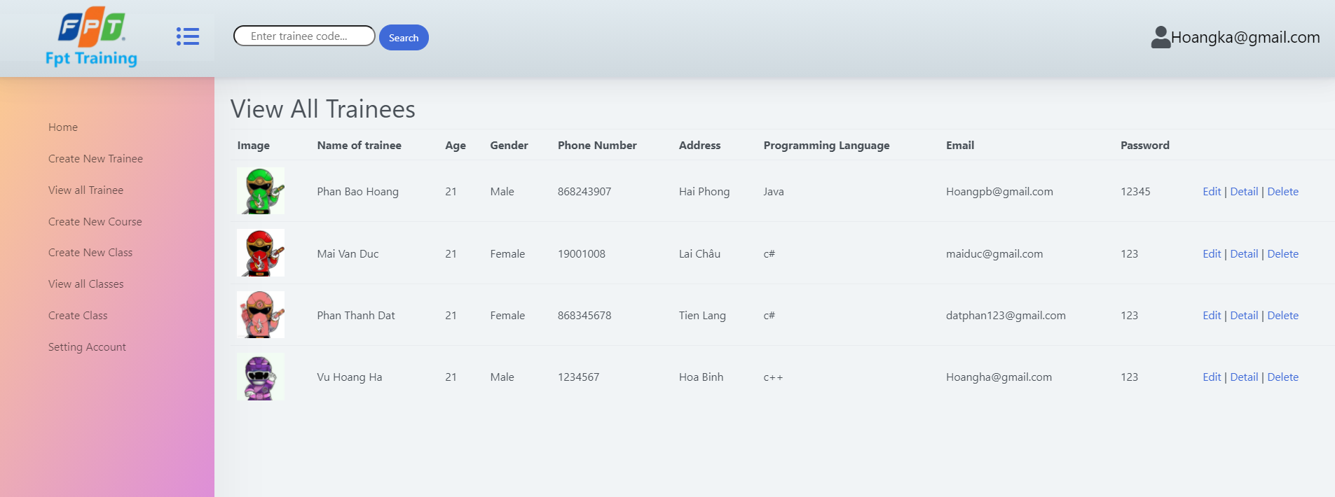

Figure -View all Trainees

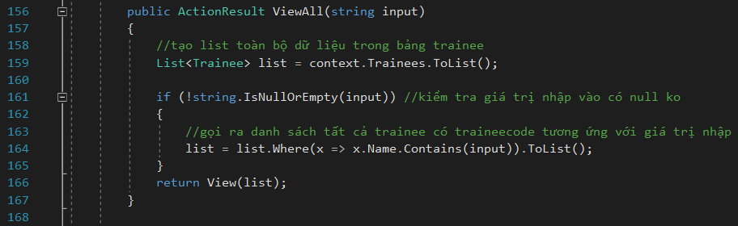

To display list of trainees, program declare variable “list” to list all of trainee in database. Besides, find trainee follow name of trainee, program check condition. To details, if there is any value that is inputted to search bar, System will display all of trainee in database that has Name of trainee same as input value.

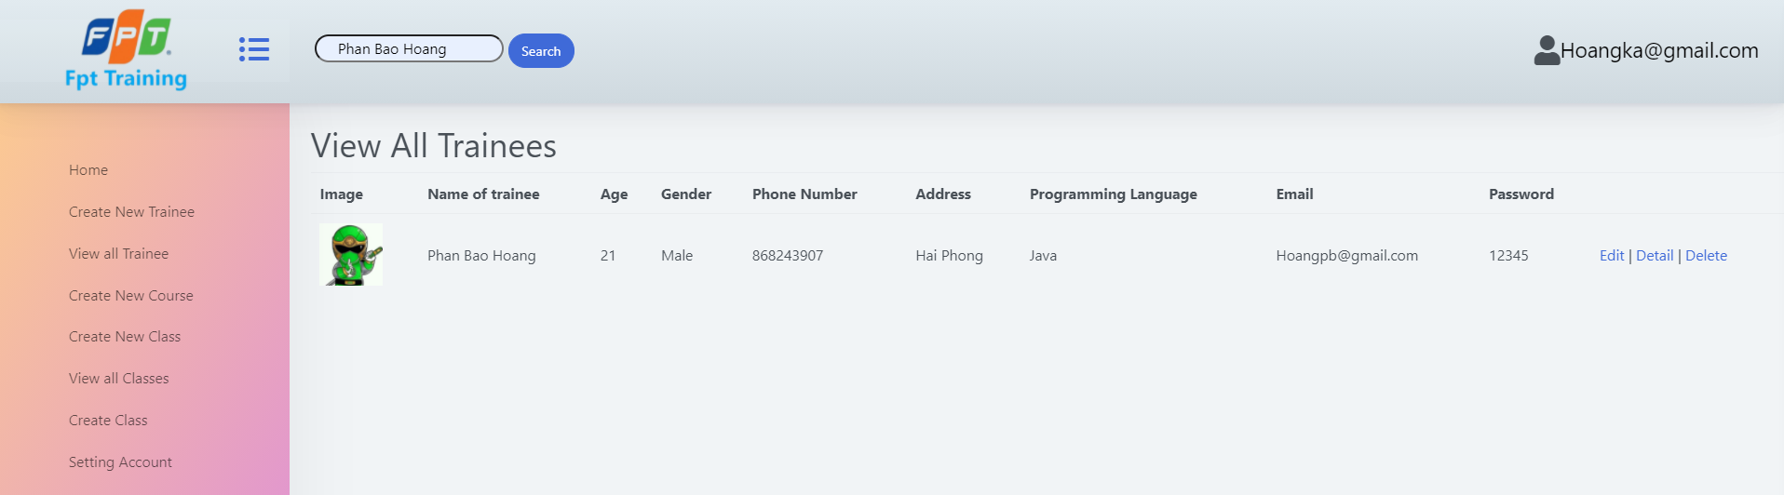

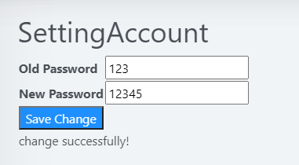

Figure -Setting account

Setting account is place where users can change their password. They must input their old password and new password to save change. After that they can click to “save change” input to save new password to database.

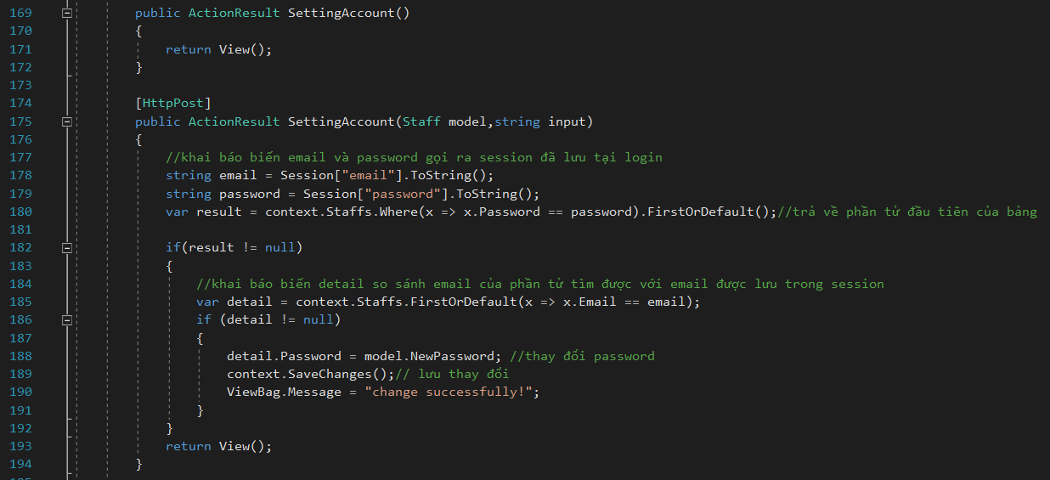

In source code program has two actions SettingAccount() with method get and SettingAccount(Staff model) with method post. In method post, program declare 2 variables email and password are two sessions that stored when user login to system. Next, program declare variable “result” to find first staff which has email same as email in session. Check if there is any qualified staff, change new password equal old password and save change it and give a message “change successfully!”.



Declare string NewPassword in Staff.cs

## Trainer System and trainee system

The system is not perfect yet so the functions of trainer and trainee are similar. Therefore, this report only talks about trainer system.

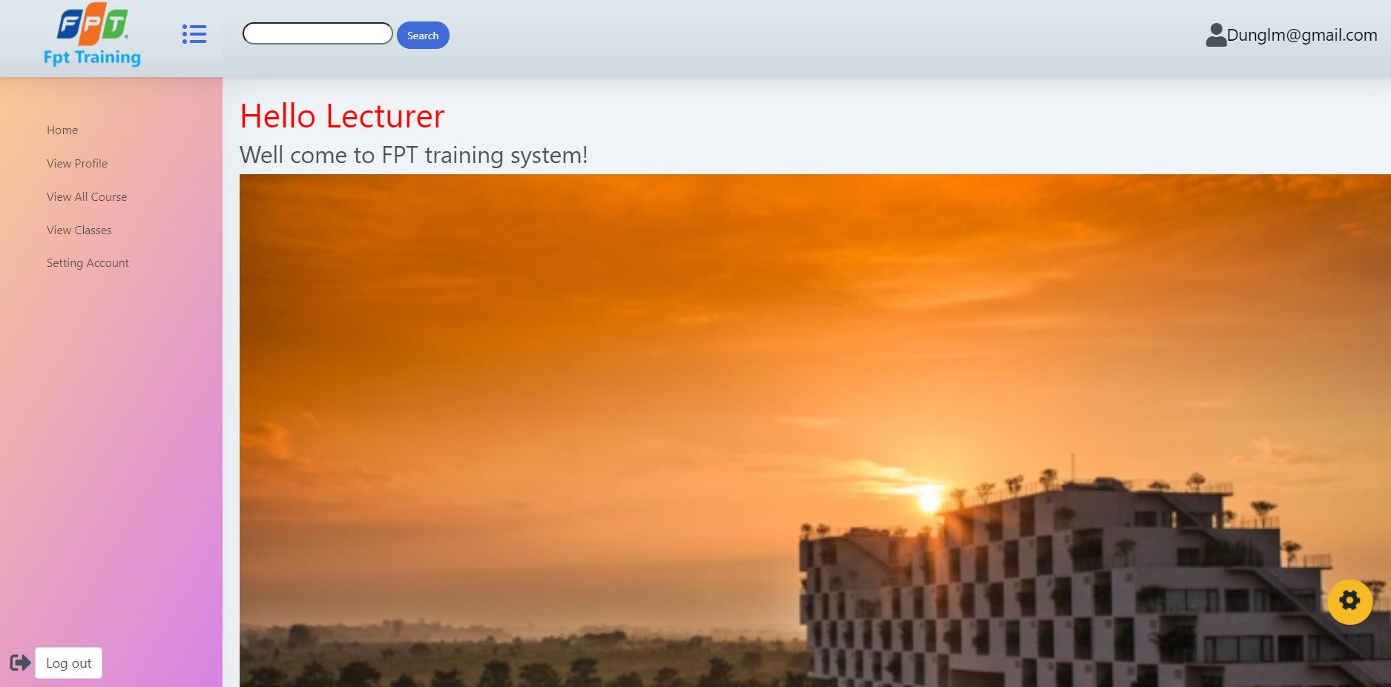

Figure -Trainer system interface

Trainer interface is the same as training staff interface. It al so has logo FPT, menu column, Email in right corner, “logout” button and a search bar to search course in the system.

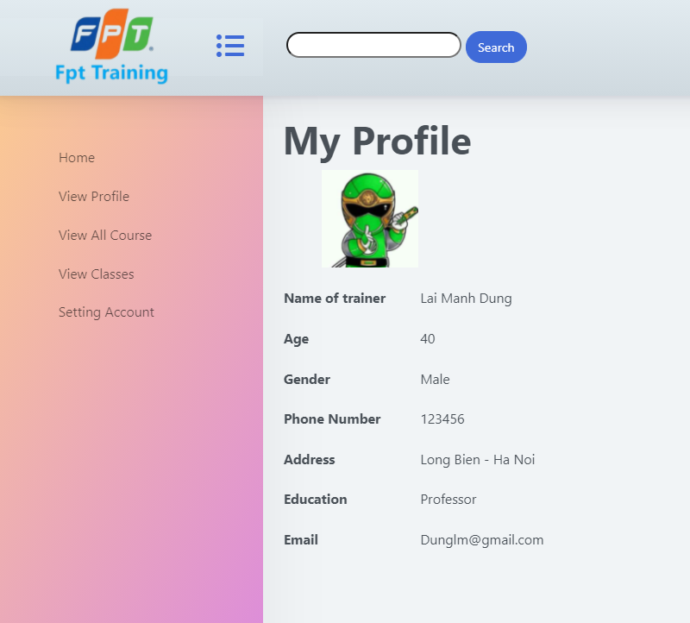

Figure -View Profile

When user’s login to system, they can click to “View Profile” to see their profile. It includes: image off user, name, age, gender, phone number, address, email and with trainer system will display education of them.

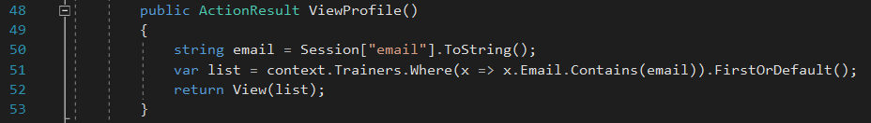

To display profile of user, program declare a variable email to call Session[“email”] which is stored when user login to system. After that, declare variable list to find the first trainer in database which has email same as Session[“email”]. And return this trainer.

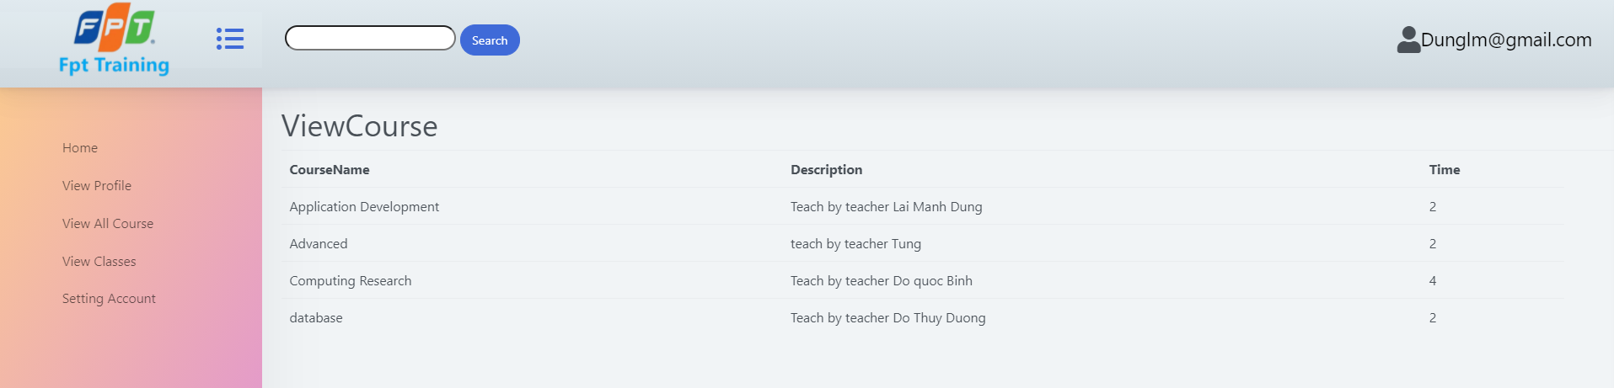

Figure -View Course

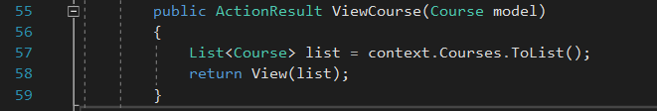

When user click to View All Course, they can see all of course in system. They can know name of course, detail description about system and time of course. To display all of course, program declare a variable list to get all of course in database, and return them.

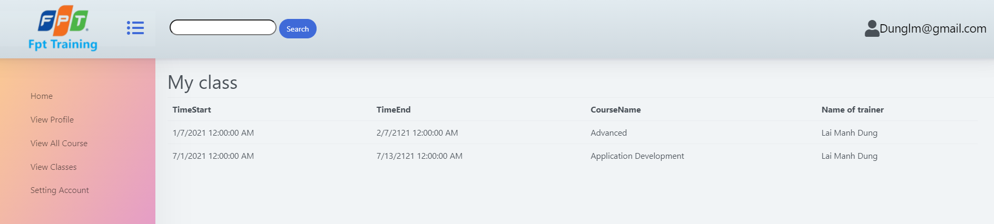

Figure -View classes

When trainer login to system they can see all of class that they will join

# Screenshots of using GitHub to manage the source code

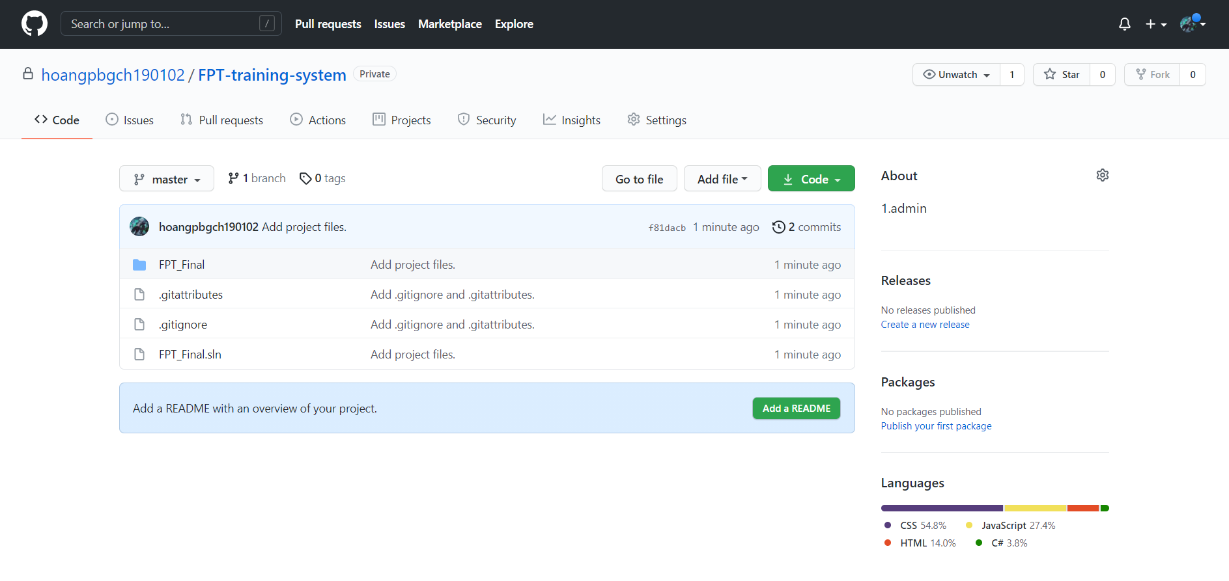

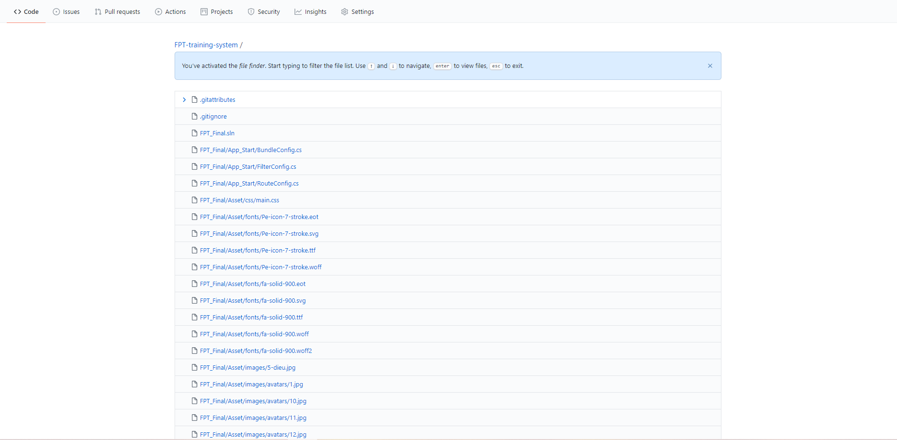

Figure -GitHub (manager source code)

I use GitHub to up source code of project. So, our team can do teamwork on GitHub directly. Besides, I also use GitHub to store all of source code of my project to avoid losing the whole project from my computer. **https://github.com/hoangpbgch190102/FPT-training-system**

# Test case

|  |  |  |  |  |
| --- | --- | --- | --- | --- |
| **Role** | **Test case** | **Expected result** | **Actual result** | **Status** |
| Admin | login | When entering a valid email and password: Login successfully. | When entering a valid email and password: Login successfully. | pass |
| When entering a invalid email and password: login failed, give error message | When entering a invalid email and password: login failed, give error message | pass |
| View, add edit, delete Training staff | View, Add, Edit, Delete successful | View, Add, Edit, Delete successful | pass |
| View, add edit, delete Trainer | View, Add, Edit, Delete successful | View, Add, Edit, Delete successful | pass |
| Training staff | login | When entering a valid email and password: Login successfully. | When entering a valid email and password: Login successfully. | Pass |
| When entering a invalid email and password: login failed, give error message | When entering a invalid email and password: login failed, give error message | Pass |
| View, add edit, delete Trainee | View, Add, Edit, Delete successful | View, Add, Edit, Delete successful | pass |
| View, add edit, delete Course | View, Add, Edit, Delete successful | View, Add, Edit, Delete successful | pass |
| View, add edit, delete Class | Add more students at the same time | Can’t add more students at the same time | false |
| Setting account | Can change password of staff | Can change password of staff | pass |
| Trainer | login | When entering a valid email and password: Login successfully. | When entering a valid email and password: Login successfully. | pass |
| When entering a invalid email and password: login failed, give error message | When entering a invalid email and password: login failed, give error message | pass |
| Trainer | View profile | Can see the profile of the user who just logged in | can see the profile of the user who just logged in | pass |
| View course | Can see all course in the system | Can see all course in the system | pass |
| View Class | see all assigned user classes | Only view all class | false |
| Setting account | Can change password of staff | Can change password of staff | pass |
| Trainee | login | When entering a valid email and password: Login successfully. | When entering a valid email and password: Login successfully. | pass |
| When entering a invalid email and password: login failed, give error message | When entering a invalid email and password: login failed, give error message | pass |
| View profile | Can see the profile of the user who just logged in | Can see the profile of the user who just logged in | pass |
| View course | Can see all course in the system | Can see all course in the system | pass |
| View Class | see all assigned user classes | Only view all class | false |
| Setting account | Can change password of staff | Can change password of staff | pass |

Test case results show that our system works quite well, user functions are clearly established. Permissions are given to the trainer, staff, admin and trainee. each user has different roles and capabilities. functions add, delete, and delete functions are working properly and no problem. However, for the trainee part and trainer part, the system still does not display the class that the trainee and trainer is assigned to. In terms of security, the system allows users to login and logout. When the user logs in with the correct account, the user will be redirected to the interface to which that user is authorized. The system almost fully meets the requirements of the company.

# Answer question of survey and interview

1. Survey

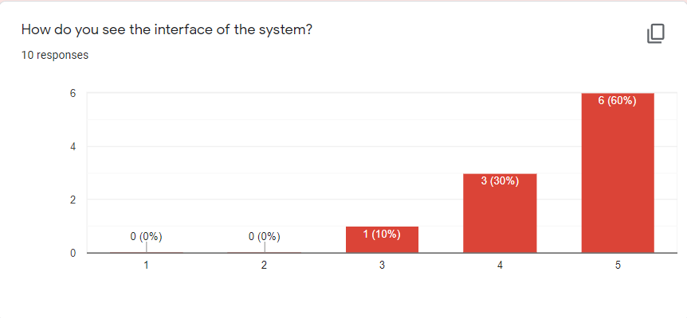

Figure -First answer

In first question, we ask people about interface of FPT training system. To details, it about: layout, color, … So, in here, there are 6 people give max mark, 3 people give 4 and a person give 3. Our system has a pretty decent layout. Everyone who has experienced the system gives an above-average score for the interface of the system. Therefore, it can be said that our system has a pretty good layout.

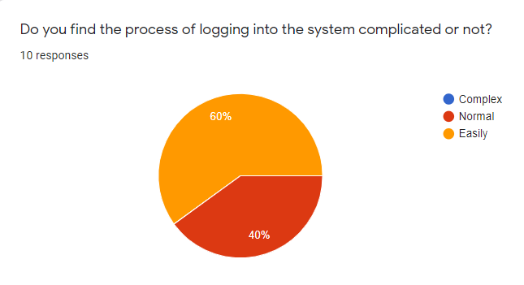

Figure -second answer

In second question, we ask people about process of logging into the system. There are 60% people think it's easy to log in, and 40% think it's still a bit complicated. Therefore, our login system still has many limitations.

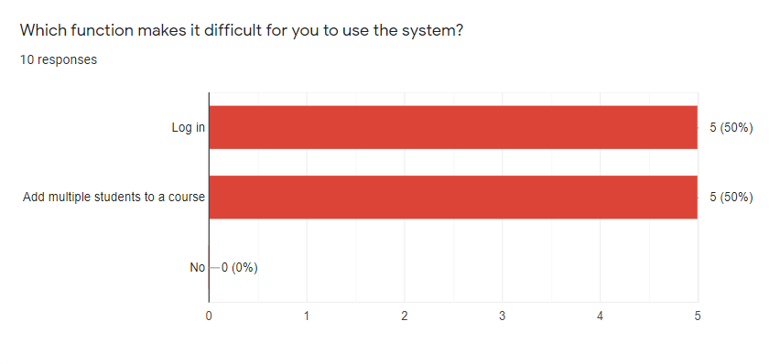

Figure -Third answer

In this question, we ask people about a function in the system that makes people uncomfortable to use. So, there are 5 people think it’s login and the remaining 5 people think it’s added multiple trainees to the class.

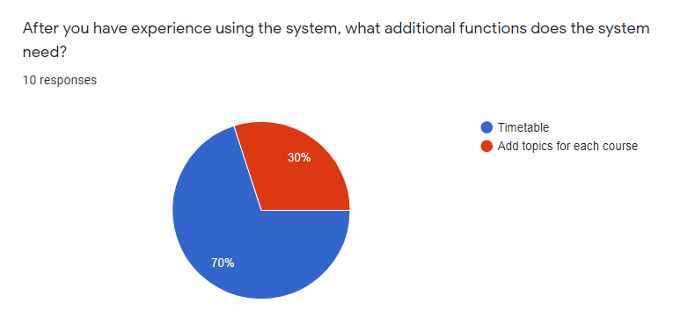

Figure -fourth answer

In this question, we ask people to choose the most necessary function for the system. It includes: timetable and add topics for each course. There are 70% of people think the system have to have timetable for trainer and trainee.

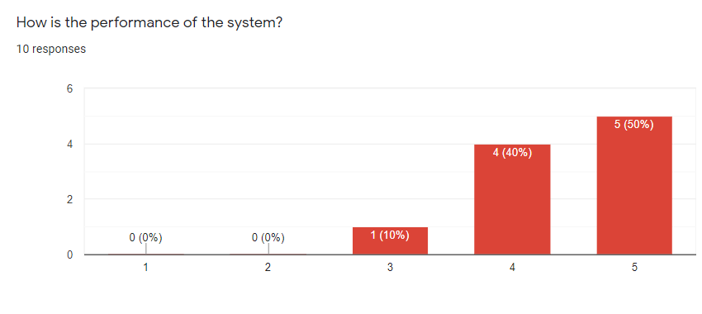

Figure -fifth answer

In this question, we ask people about performance of system. So, there are five people give us 5, 4 people give 4 and only person give 3.

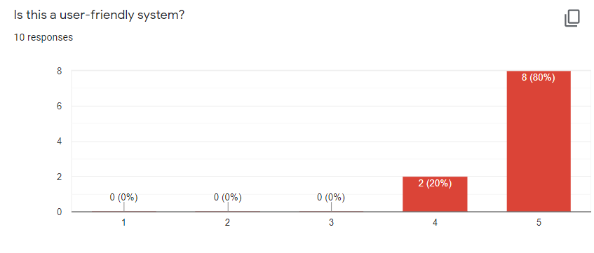

Figure -sixth answer

In this question, we ask people about user-friendly of system. There are 80% of people give us max mark and 2 people give 4.

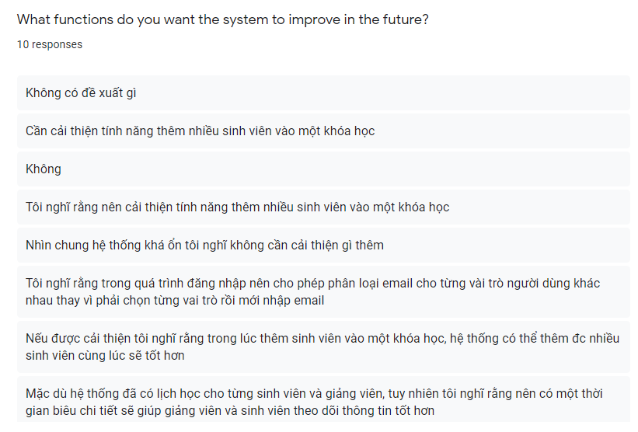

Figure -seventh answer

This is an open-ended question asking people to give suggestions for functions that need improvement or future development.

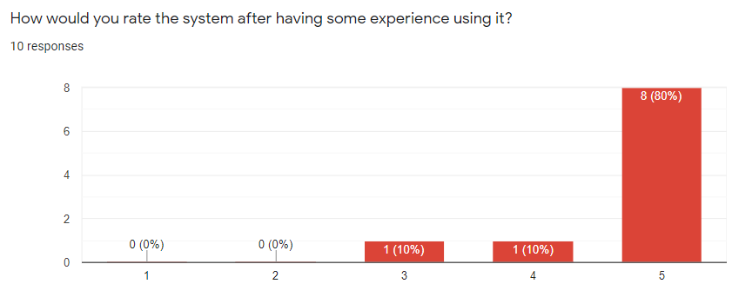

Figure -eighth answer

There are 8 people think that the system only improves some function, then it can be applied in practice.

Through surveying everyone who has experienced the system, we draw several conclusions. First, our system is quite user-friendly: the functions are easy to use, not fussy, the color of the system can be changed according to each person's preferences. The performance of the system is quite high, it can be used in environments with many users such as schools and companies. However, besides that, the system still has a lot of limitations that annoy users. The login system is still complicated, not smart, making some people unhappy when they have to choose a new role to log in. Besides, not adding many trainees at once takes time and annoys users. In short, our system needs to improve many more functions to complete and put into practice.

1. Interview

|  |  |
| --- | --- |
| **Question 1: Can you introduce yourself a little bit?** | |
| Nguyen Van Duc | Hello everyone, my name is Nguyen Van Duc, I'm currently a third-year student at the University of Greenwich Vietnam, I'm majoring in information technology. |
| Doan Anh Tu | Hello, I'm Doan Anh Tu, I'm currently 21 years old and majoring in information technology at the University of Greenwich. |
| Vu Ngoc Tu | My name is Ngoc Tu, I'm currently a student at FPT University, majoring in information technology |
| **Question 2: Have you ever used a system similar to ours?** | |
| Nguyen Van Duc | Yes, while studying at school, I used a system similar to yours, the CMS system. |
| Doan Anh Tu | I used a system quite similar to yours, the University of Greenwich AP system |
| Vu Ngoc Tu | I did a project similar to your last semester and I also used a real system which is the university CMS system. |
| **Question 3: How do you find our system different from other systems?** | |
| Nguyen Van Duc | In general, the way your system works is quite similar to the system that I used, the system also assigns courses for trainers and trainees. |
| Doan Anh Tu | As for the system I used, it's not much different from yours |
| Vu Ngoc Tu | Your system is quite similar to the one I used at the university, but for your system can only view your courses, and the trainer has not yet created the directories for trainees submit reports |
| **Question 4: What do you think about the functions of the system?** | |
| Nguyen Van Duc | I think your system has basically met the functions of an education management system. After using, I found that the system helps a lot for employees when they can assign courses to employees, Trainers and trainees will see their course information and display information very easily |
| Doan Anh Tu | I find the system's functions help me see my subject information, its subject and who teaches it, in addition, I can view my class schedule very easily. |
| Vu Ngoc Tu | After using the system, I found that the functions are basically quite good and suitable for educational management. |
| **Question 5: What do you think about the performance of the system?** | |
| Nguyen Van Duc | I found the system to be performance guaranteed, it is quite fast, the response to the functions is about 3 seconds |
| Doan Anh Tu | System overview, the response speed is generally ok, however, I have problems creating accounts for staff as Admin, sometimes this function causes a certain delay |
| Vu Ngoc Tu | As for the system performance, I feel pretty good, your site usually responds in 3 to 4 seconds, I think that response time is quite ok for a user like me |
| **Question 6: Are you satisfied with our system? What makes it difficult for you to use our system?** | |
| Nguyen Van Duc | I am quite satisfied with this system, however, what makes it difficult for me to use the system is the login function. Every time I log in, I need to select a user role and then enter my account and password, so this makes it a bit difficult for me to use the system. |
| Doan Anh Tu | I am quite satisfied with the functions it gives me at the moment |
| Vu Ngoc Tu | I am satisfied with the system, if I talk about one thing that makes it difficult for me to use the system is when I use the function to add trainees to a course, you should have a function that displays suggested lists trainee, this will make it easier for users to add more trainees |
| **Question 7: What functions do you think our system needs to improve in the future?** | |
| Nguyen Van Duc | I hope that in the future the system can add a timetable interface for trainers and trainees can easily view the schedule information in more detail. |
| Doan Anh Tu | I think your system needs to change a bit about the interface to make it livelier and more suitable for the education management system. |
| Vu Ngoc Tu | I think, in the role of a trainer, in the future, the system needs to add a feature to create exercise folders for trainees. And trainers and trainees need more timetables |

**Video link recorded the interview:**

Nguyen Van Duc: <https://www.youtube.com/watch?v=l-xoKH3QNCU>

Doan Anh Tu: <https://www.youtube.com/watch?v=BlyHmYyNafI>

Vu Ngoc Tu: <https://www.youtube.com/watch?v=fioaJ24xl-o>

Through interviewing 3 people Nguyen Van Duc, Vu Ngoc Tu and Doan Anh Tu, we can come to the following conclusions. This is a training management system, so it is quite similar to the student management system of the University of Greenwich. However, with our system they have some new experiences compared to the school system, but there are still many limitations. Nguyen Van Duc is not satisfied with having to add students one by one and in a class, it takes time and effort. You Vu Ngoc Tu wants the login system to be smarter to recognize the account type, but not to choose a role before logging in. Besides, all 3 people think that the system has a nice interface and can change colors; user-friendly, easy-to-use functions; Many people access at the same time but the performance of the system is quite good. They all think that the system can be practically applied if some functionality is improved in the future.

# Evaluate the strengths and weaknesses of the application

In summary, FPT training system is basically completed. However, besides the advantages of the system, there are still limitations that need to be improved in the future to bring high efficiency in practice. To details, I will show the strengths and weaknesses of the system.

* Strengths
* Beautiful interface, people can change the color according to their preferences.
* User-friendly system, easy to operate.
* Performance is quite good, allowing many people to access at the same time.
* Weaknesses
* The login system is not smart.
* Some functions are still limited, need further improvement
* Lacks a few functions to be able to apply in practice

In the future, we will work to add timetable functionality for trainers and trainees. This is a course management system, so this is a necessary function to help trainers and trainees understand their own learning and teaching process. Based on the current classes, we will provide a timetable for each class, through which each trainer and trainee assigned in that class can view the class timetable. This is an important function in a training management system, but due to lack of time, in the future we will add this function to the system to make it completer and more applicable in practice. number of schools or more is university.